**ECE 6213 – Design of VLSI Circuits**

**Fall 2022 – The George Washington University – Dr. Jerry Wu**

**Osama Yousuf – HW 4**

**Problem 1 – Chapter 7 P2 from textbook – UART Clock Generator**

The following is a breakdown of my implementation of the different modules for the UART_Clock_generator, as well as corresponding verification tests.

**Module 1:** Divide_by_13

For verification, I simply recreated the waveforms from the book.

The source file is: *divideby13.v*, and the testbench is *divideby13_tb.v*

**Module 2:** Divide_by_8

For verification, I simply recreated the waveforms similar to Module 1. The output “clock_by_8” is high when the internal counter variable asserts a value of 7 (in line with clk_1 from the previous code).

The source file is: *divideby8.v*, and the testbench is *divideby8_tb.v*

**Module 3:** Divide_by_256

For verification, I simply recreated the waveforms similar to Module 1. The output “clock_by_256” is high when the internal counter variable asserts a value of 255 (again, in line with clk_1 from the previous code), as shown in the attached waveform.

The source file is: *divideby256.v*, and the testbench is *divideby256_tb.v*



The 8-bit counter is exposed as an output since it has to be used as an input to the multiplexer for the UART_Clock_Generator module.

**Module 4:** 8 to 1 multiplexer

The source file is: *8to1mux.v*, and the testbench is *8to1mux _tb.v*

For testing, I initialize each of the 8 inputs randomly, cycle through the select pins, and assert the correct output. I also implemented error monitoring, watchdog signals, as well as self-reporting in my testbench. The testbench executes with 0 errors.

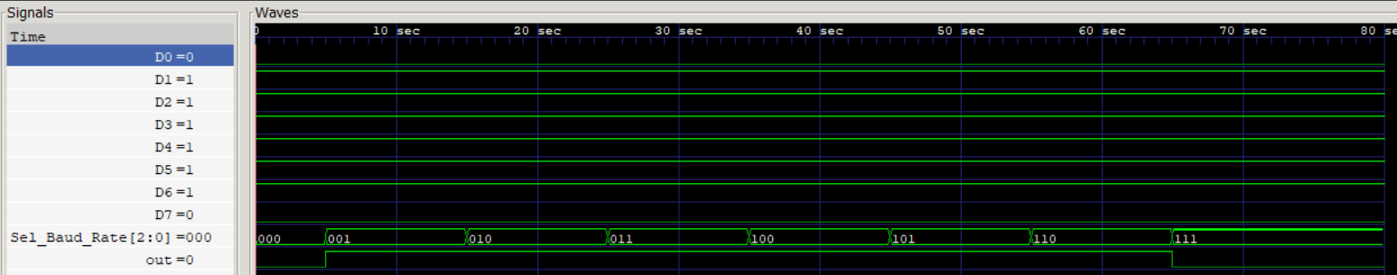

The waveform shows that the inputs are indeed correctly multiplexed on the out pin, based on the 3-bit Sel_Baud_Rate input pin.

**Overall Module:** UART_Clock_Generator

For verification, my testbench cycles through the 8 possible values of the “Sel_Baud_Rate” pin, and calculates the frequency of the two generated clock signals “Clock” and “Sample_Clock” at a specified resolution parameter. This resolution parameter relates to how long the UART_Clock_Generator is allowed to run (in time cycles) at a given Sel_Baud_Rate value. For example, a resolution of 0.05 translates to a total time of 0.025 seconds per Sel_Baud_Rate, and a higher resolution of 2.00 translates to a total time of 1 seconds. The frequency of Clock and Sample_Clock is simply extrapolated for a given resolution.

Verification results at different resolutions are presented below.

1. At very low resolution (0.025 second)

1. At medium resolution (0.05 second)

1. At high resolution (1.00 second):

As can be seen, the frequencies of “Clock” and “Sample_Clock” both converge to the true frequencies described in Table P7-2 in the book, shown below. I did not have the computing resource to compute the values at a higher resolution (for example, 10.00 seconds). The reported frequency values of the baud rate pairs from my testbench at a resolution of 1.00 seconds are within a range of +-5% from the true values from the book, and so are acceptable to justify the verification for our purposes.

The source file is: *uart.v*, and the testbench is *uart _tb.v*

**Note:** I have used error monitors, watchdog for finishing my simulations, self-checking, self-reporting, verilog events and tasks, and $random timings in my testbenches.